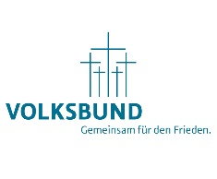

Dear Sir or Madam,

On the occasion of the German Memorial Day ´Volkstrauertag´, a ceremony will be held at the German Military Cemetery in Lommel (Belgium) on Sunday, 14th of November 2019 at 01:00 pm.

We want to remember all victims of war and violence all over the world in the spirit of the ideals of the German War Graves Commission: “Reconciliation over the Graves – Work for Peace”.

We cordially invite you, your family and interested friends to both events.

In case of participation, please respond by e-mail or mail in due time. The programme of the ceremony is enclosed as annex to this letter.

“Please comply with the current COVID measures. However, it is impossible to predict these. Please therefore personally consult the necessary information on various media, including our website www.huisovergrens.eu. Specific rules will be communicated on site. In any case, you are asked to bring a mouth mask and your COVID certificate.

Sincerely,

Yvan VANDENBOSCH H.E. Martin KOTTHAUS Myriam KOONINGS
Representative VDK e.V. in Belgium German Ambassador Director
Colonel GS (ret) to the Kingdom of Belgium Youth Meeting Center Lommel

Voor de tekst in het Nederlands, zie: www.overgrenzen.eu
Pour une traduction française, veuillez surfer sur: www.overgrenzen.eu
Eine deutsche Übersetzung finden Sie unter: www.overgrenzen.eu

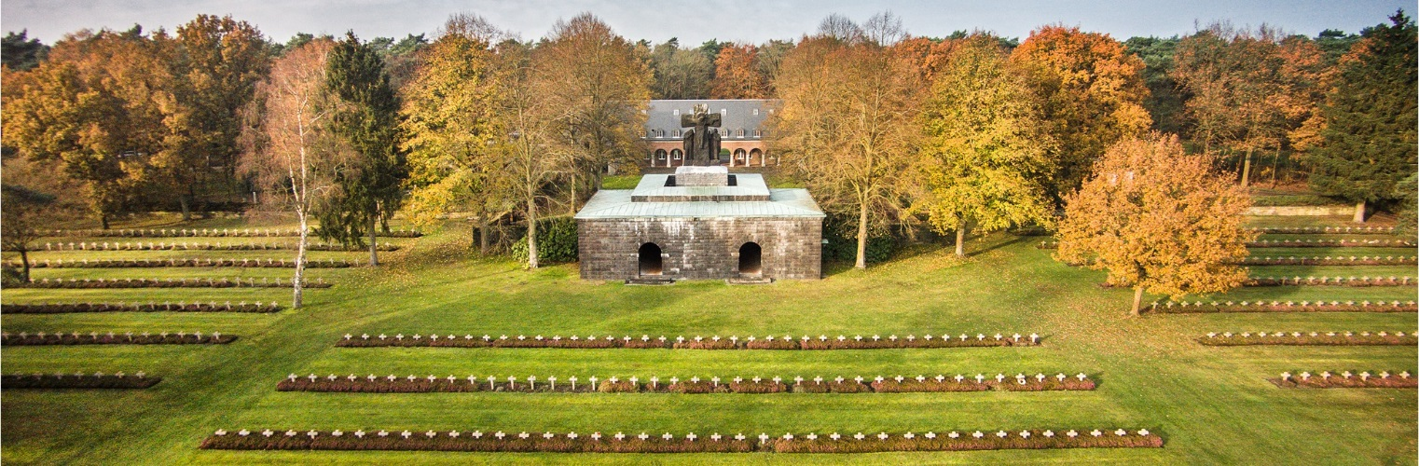

INVITATION: COMMEMORATION CEREMONY´VOLKSTRAUERTAG´

WHEN? Sunday, 14th of November 2021
WHERE? German Military Cemetery Lommel /International Youth Center ´Huis over Grenzen´, Dodenveldstraat 30, B-3920 LOMMEL
START? 01:00 pm commemoration “Volkstrauertag”
ENTRANCE: The entrance to the ceremony is free.

PROGRAMME

01:00 pm: START OF COMMEMORATION CEREMONY
Welcome on behalf of ´Volksbund Deutsche Kriegsgräberfürsorge e.V.´
Erik De Muynck, Honorary Colonel GS (Ret.), Representative Volksbund Deutsche Kriegsgräberfürsorge e.V. for Belgium
Contribution German International School Brussels
Speech
Priest F. Kossmann
EH Wolfgang Severin, Sankt Paulus.
Creative presentation
Pupils from the Wico campus St. Jozef (B)
Commemoration speech
French Ambassador ?
Remembrance of the dead
H.E. Martin Kotthaus, Ambassador of the Federal Republic of Germany to the Kingdom of Belgium
Wreath-laying ceremony
Reception

The Royal Band of the Belgian Navy provides the musical framework playing a repertoire of different pieces like the ´Last Post´ and national and international hymns. Furthermore, a guard of honour of the School NCOs from Sint Truiden (B) will participate in the ceremony.

ENTRY FORM TO THE COMMEMORATION CEREMONY ´VOLKSTRAUERTAG´
ON 17 NOVEMBER 2019

Please respond by e-mail, fax, phone or mail using this entry form. Please send this document for November 5th 2019 to Huis Over Grenzen.

NAME:

ORGANISATION:

ADDRESS:

TEL:

E-MAIL:
Please excuse me

I would like to receive future invitations by e-mail.

I will attend with person/people

I will lay a wreath. (There is the opportunity to lay a wreath during the ceremony. Wreaths shall be delivered not later than 12:30 pm)

